Radial Reconstruction User Manual
David Schoenberg

Table of Contents
Introduction
Getting Started
Basic Features
Reconstruction
Phantom
Advanced features
Viewing Images
Developer Information
Tips & Tricks

Introduction
This is a user manual for the two main GUI (Graphical User Interface) programs contained in this folder. They are:
- Radial_Reconstruction_App (“Reconstruction”): This app loads the data from the scanner and uses the two grads reconstruction method to reconstruct the image. It loads the image and saves the reconstruction in the original data folder. It stores a log of the parameters used in the reconstructions in log.csv.
- phantom_app (“Phantom”): This app creates a phantom in a format readable by the Reconstruction app. It saves the phantom in the folder phantom_objects. Uses some data from the previously performed reconstruction to create the phantom.

Getting Started
[NOTE: Screenshots were made on MacBook, but instructions are the same for a windows device.]
Open MATLAB. In the command window type in:
guide
This launches the guide app browser:
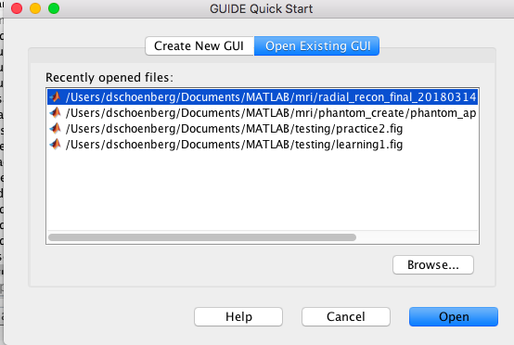
If the app you are looking for doesn’t show up, browse for the correct one. In this case, you are looking for either Radial_Reconstruction_App.fig or phantom_app.fig.
Once you have selected the correct app, something like this will load (depending on the app). This is the editor for the GUI. DO NOT MOVE ANYTHING AROUND:
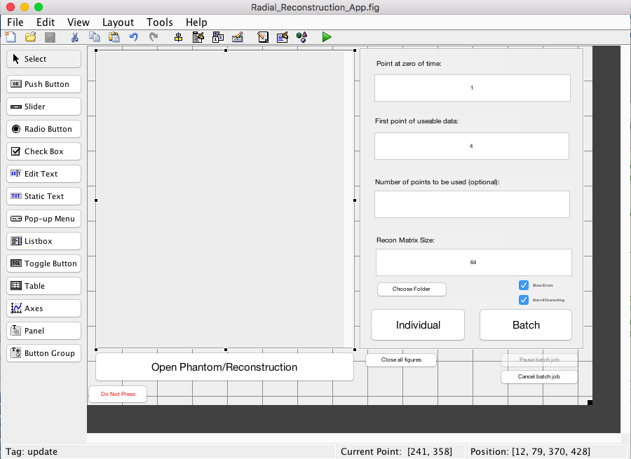
Click on the green triangle. This will load the actual app.
You will likely see a message like this:
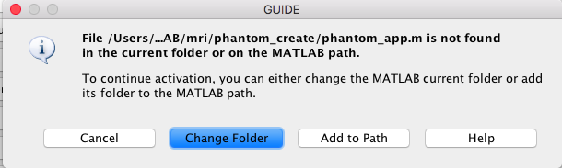
Select Add to Path. Selecting Change Folder will also work, but it could cause problems should you decide to run both applications at once or use MATLAB for another purpose while the Reconstruction/Phantom is running.
[You can also open the app by navigating to the folder the app is in and typing the name of the app (phantom_app or Radial_Reconstruction_App).
Basic Features
- Reconstruction:
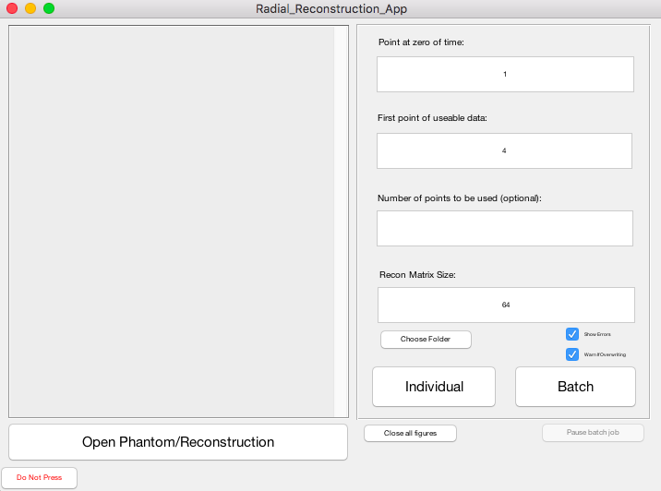
This is the interface for the Reconstruction. The left side is an update box. It will keep you apprised of the progress of the reconstruction and list any errors.
The right side contains options for the reconstruction. The editable boxes are parameters (with preset defaults). Beyond that:
- Choose folder: select the folder containing the dataset(s). The currently selected folder name will appear beneath the button. See Types of Reconstruction below.
- Show errors: makes it so you get a nice popup when there’s an error in the reconstruction. Recommended for individual reconstructions but not for batch reconstructions.
- Warn if overwriting: see Advanced Features section.
- Close all figures: this closes all open figures, except the Reconstruction app and, if it’s open, the Phantom app.
- Do not press: Don’t press it. See Developer Information section.
- Pause batch job: See Advanced Features section.
- Cancel batch job (not pictured): See Advanced Features section.
Types of Reconstruction:
- Individual:
Run a reconstruction on a single data set. When choosing the folder, select the one that contains the data. For scanner reconstruction, this is the folder with the 4-digit number. For phantom reconstruction, this is the folder with the phantom name.
- Batch
Run a reconstruction on a series of data sets. When choosing the folder, select a folder that contains all of the data set folders you want to reconstruct.
- Example. Say you have files like this:
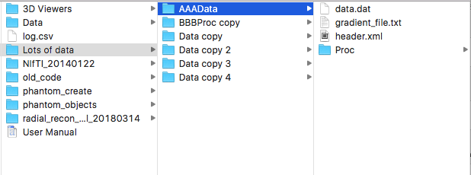
Each Folder in “Lots of data” is its own data set—i.e., each one represents the output of a single scan/phantom. To run a reconstruction on say, AAAData, click Choose Folder, navigate to and select AAAData, and then run the individual reconstruction. In contrast, to run a reconstruction on all of the files in Lots of data, click Choose Folder, navigate to and select Lots of data, and then run the batch reconstruction.
Once each reconstruction has been performed, the reconstruction will load in an image viewer. See Viewing Images section for more details.
- Open Phantom/Reconstruction: See Viewing Images section.
- Phantom
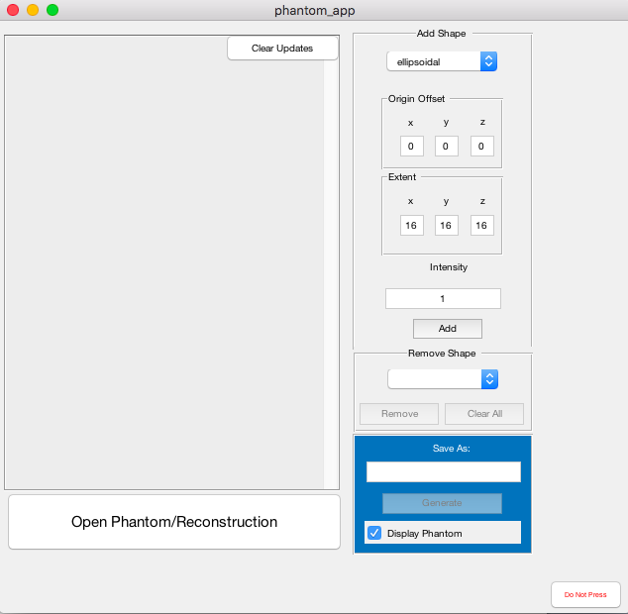
This is the Phantom interface. With it, you may add a series of shapes in 3D space and then generate a dataset that can be used to test the reconstruction.
The left side is an update box. It will keep you apprised of the progress of the reconstruction and list any errors.
The right side contains the options you can edit:
Add Shape
- [Top drop down]: Shape type: you can currently add either an ellipsoidal or a rectangular shape
- Origin Offset: the distance from the center of the phantom to the center of 3D space in the x, y, and z directions.
- Extent: the radius/one half the side length in each of the x, y, and z directions.
- Intensity: desired intensity of this shape in the phantom.
- Add: add the specified shape to the phantom to be created.
Remove shape:
- Select via the dropdown menu and remove a given shape from the phantom.
- Clear All: clear all shapes from the phantom (start over).
Generate shape
- Save as: name for the phantom (what the folder will be called).
- Generate: generate the phantom from the given shapes.
- Display Phantom: load phantom in image viewer after creation. See Viewing Images section.
Other
- Clear updates: clear the updates window.
- Do not press: don’t press this button. See Developer Information Section.
- Open Phantom/Reconstruction: See Viewing Images section.

Advanced Features
- Reconstruction
Multiple Reconstructions of Same Data:
The software automatically saves the first reconstruction of each data set within the data set folder as “reconstruction.mat”. If you choose to do a second reconstruction of the same data set (say with different parameters), you run the risk of overwriting the previous reconstruction.
There is therefore an option to warn if a previous reconstruction is being overwritten.
When this is checked and a reconstruction already exists for the data set, a popup will appear asking whether you want to rename the new reconstruction. It gives 10 seconds for you to begin typing before it closes automatically and skips the reconstruction. (This time limit is particularly helpful for batch jobs so it doesn’t get stuck on one batch job.) If you leave the box blank, the program will overwrite the previous reconstruction. If you hit cancel, close the window, or wait 10 seconds, the reconstruction will be skipped. If you choose a new name, it will check whether that name has already been used, and if it has, give you the same prompt with the same options.
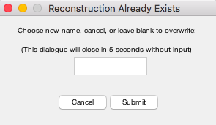
Batch Job Errors
When there is an error in a batch job reconstruction, the program will wait 5 seconds before continuing with the next reconstruction. This gives you time to hit the pause button if you need to.
Pause/Cancel Batch
When you start a batch, the pause batch button becomes enabled. It waits until the end of the reconstruction it is on and pauses the reconstruction. The pause button then becomes the continue button which allows you to continue. A cancel button also appears once you have paused. This allows you to stop the rest of the batch (reconstructions that have already been performed will remain saved).
- Error Detection
Both applications attempt basic error detection, including detecting invalid inputs and ensuring that buttons are only press-able/only do things when they should.

Viewing Images
There are a few ways to view a reconstruction/phantom. The easiest is when a reconstruction is generated, it automatically loads onto your screen. When a phantom is generated, the Display phantom checkbox determines whether it will automatically load onto your screen. To view a previous reconstruction, hit the “Open Phantom/Reconstruction” button in either app. This will show you a file viewer. Navigate to and find the original phantom/reconstruction. For original phantoms, this will be called phan_true.mat. For reconstructions, this will usually be called reconstruction.mat, but may have another name (always ending in .mat) if you specified one (See Multiple Reconstructions of Same Data, above.)
The image viewer looks like this:
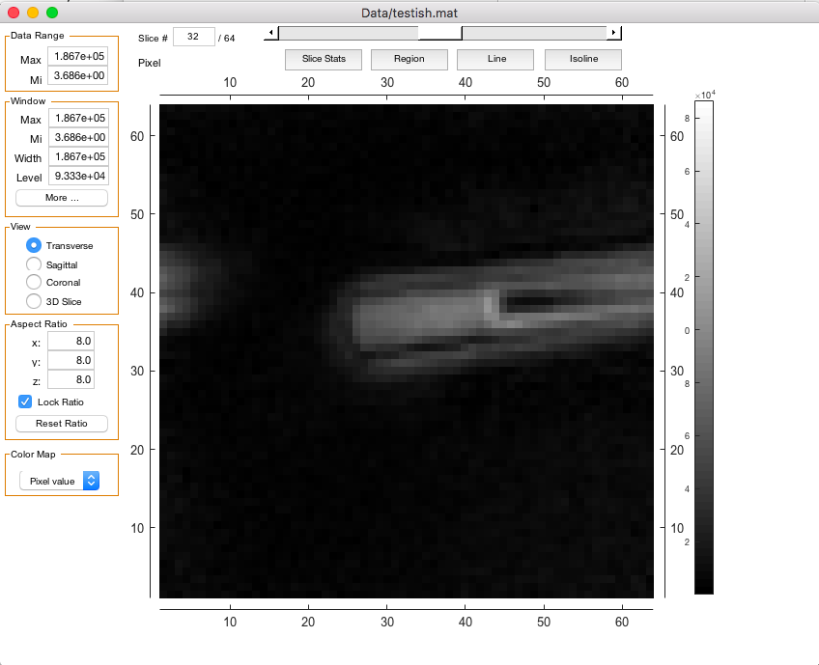
- Use the scroll wheel to scroll through slices
- Click and drag sideways to change the window width
- Click and drag up/down to move the window
- To reset window, click “More…” and then Reset
- In 3D slice mode, right click and drag to move sliders
- More details: https://www.mathworks.com/matlabcentral/fileexchange/47594-3d-image-viewer-and-slicer
- Pixel location/value is shown in the upper left

Developer Information
Folders:
The important folders/files are:
- 3D Viewers: contains the viewer(s) used. Currently, the only one needed is vi, but theoretically, another one/better one could be put in and used pretty easily (just change it from vi in run_reconstruction, phantom_app.m, and Radial_Reconstruction_App.m.
- Phantom Create: where the code for the phantom creation lives.
- Phantom Objects: where phantom objects are stored after they have been created (this is declared in pseudo_data_phantom at the end).
- radial_recon_final_20180314: where the code for the radial reconstruction lives.
- log.csv: contains the log of reconstructions performed.
These folders absolutely must stay in the same overall folder. The name of the overall folder doesn’t matter as long as they are all directly within it.
The Red Button:
If you only ever use the GUI, you should never need to press this button. This button helps debug things by putting certain variables within the scope of the command line (most importantly, handles). If you don’t know what scope means, you definitely should not be pressing the button, except maybe for one thing below.
The one use you might actually have for it is to reenable the GUI. Currently, the GUI disables most functions when it is running a calculation and re-enables it when it finishes. Normally, no problem. However, if you decide to go to the MATLAB command line and hit control-c, the program will stop in the middle. The GUI will remain paused.
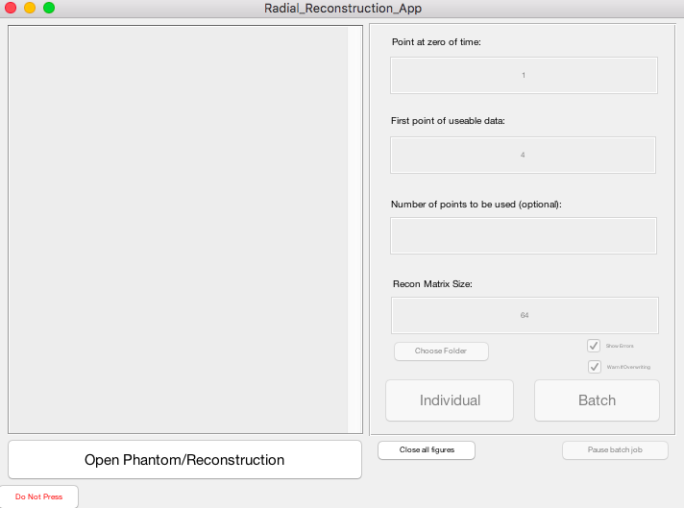
Should this happen, you can either close and open the GUI or hit the red button, run the following command, and hit the big red “Stop Debugging” button in MATLAB’s Editor tab:
Reconstruction: reset_gui(handles, hObject);
Phantom: unpause_gui;

Tips & Tricks
- You can tab around and hit enter instead of using the mouse.
  - Enter on button clicks button. Enter on textbox clicks associated button.
  - Enter in Phantom drop down menu: for add shape, moves to x offset. For remove shape, removes selected shape. You can select different options via keyboard using arrow keys and space bar.
- When choosing data for reconstructing, the code automatically starts in the current MATLAB directory:
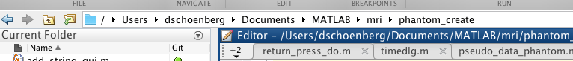
Navigate to the directory your data is in, and your life will be slightly easier.

